**User requirement**

**Definition**: As the name implies this refers to what the user wants,in simpler terms it is the structure and functionality that the user wants in the web applications.

**Introduction to our project:**

Our Project in simpler terms is a web application that would visualize thematic (dynamic) maps along with graphs for 4 variables (Precipitation, Temperature, Population, Air quality index).As of yet we haven’t taken data downloading into account which is a user requirement in its own.

As of yet the basic prototype we created (for practice purposes) is as follows

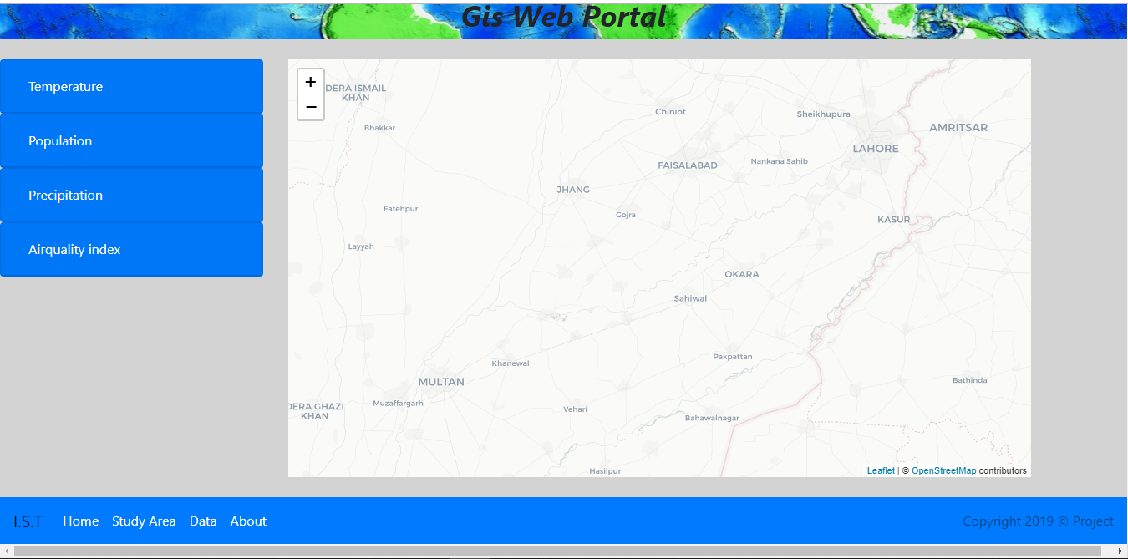

**Basic Requirements:**

* Option to download data
* Option to view the maps of the variables on the same time
* Have an interactive map and a responsive webpage
* To perform on the spot processing.
* Time slider or dropdown menu
* A large or an appropriately sized map that accurately represents your data
* Information like graphs to be shown in pop-up format
* To put more functionality on maps like the ability to make videos take picture on the web application

**Web application taken for example:**

**USGS Land-Look:**

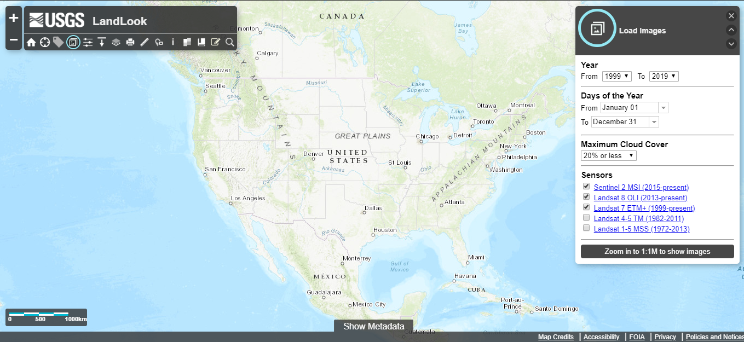

**ESA Sentinel hub EO browser:**

